Assignment #4.2d-Final Report

Hong Kong Polytechnic University
MSc in Multimedia and Entertainment Technology
Production Processes in Multimedia and Entertainment (SD5902)
December 2015

15108307g WU Meimei
15114254g LI Liwei
15114468g WU Hao
15114735g ARAT Nur Saba
15115076g SHEN Jiawen

- The Design Process
1.1 Generalizing
The aim of our project
Eventually, the aim of our project is to enhance the accessibility of iPhone for VI people. We focused on the VoiceOver technology and try to help VI people utilize this function. To realize this we tried to remove the hardships caused by the touch screen technology to allow VI people to use their mobile devices without obstructions and attach a click wheel device on the back of the mobile phones. With this integrated and unified technology, we are hoping to offer VI people an easier, one-hand operable and less confusing access compared to the touch screen technology which does not have the physical feeling of the touch. However, this idea does not come from the very beginning although the aims are similar on some aspects.

Initially, we designed to develop a voice photo application and the assistant external physical keyboard. The details could be found in the interim reports.

Identify stakeholders and their needs
VI people still have difficulties in accessing functions of iPhone, so they need a method to overcome such inconvenience.
During our interview with Mr. Mok, we have realized that even the most efficient technology user VI people like himself have problems using mobile devices. He mentioned how it is hard to find the photo he has taken afterwards within the camera roll and how he prefers a physical keyboard compared to the touch screen technology. Another important knowledge we learnt from him came out from our observations of Mr. Mok. When he used his mobile phone, he had to put it towards his ears to hear the VoiceOver and he had to use his fingers to control the phone as placed between phone and his ear.
We firstly focused on the taking photo experience of VI people but then changed to a more general topic about entirely enhancing the accessibility of iPhone for VI people. We believe VI people would like to have a better experience not only when using the camera but also a lot of other applications. To realize this potential possibility and realize this need of the stakeholders, we finalized our design.

Background research
The background research and the contextual review are mainly about the inconvenience in daily lives of VI people, the related existing technology and applications. The details could be found in previous reports.
Constraints and assumptions
The constraints and assumptions we made initially are mainly about the voice photo application. The constraints are the operating system updating issue, incorrect operation by normal people and the compatibility issue.
Technically, the basic function could be realized referring to the existing product developed by similar technology. We assume that we will connect our click wheel to the phone by headphone jack or Bluetooth. Referring to, for example, selfie stick and chargeable phone case, we may ensure the implementation of our product should be practical.

1.2 Reflection-for-action
Key Concepts
Originally, there are two key concepts:
- creating an external source which will help to create more convenient use of the mobile devices for VI people
- helping VI people to record, save, find and share the photos they take
However, we kept the first one to create an external device to enhance the accessibility of iPhone for VI people while abandoned the second one.
So the current key concept are removing the hardships caused by the touch screen technology to allow VI people to use their mobile devices without obstructions and attaching a click wheel device on the back of the mobile phones. With this integrated and unified technology, we are hoping to offer VI people an easier and less confusing access compared to the touch screen technology which does not have the physical feeling of the touch.

Measure of Success
For our external navigation device, we would like to improve an already existing technology and this will allow us to create our prototypes with the minimized cost. We are hoping to unify two or even three existing products and bring them all together in one mobile device instead of using different devices which hardly work synchronized with each other.
What we want to achieve with this product is creating more of a physical feeling of using a mobile device. Our measurement of success can be achieving using two different senses to direct the device which are both hearing and touch. Because we believe the touch screen technology of today lacks of real touch sense. This might not be important for us because we can see the effect of “touching” on our screens but VI people rely on their senses when they use this technology. Besides, the measurement of success also includes

Scenarios
Firstly, we think that our product can help VI people is that enhancing the accessibility of VoiceOver. VoiceOver requires the index finger to be on the screen while using the mobile device to hear the name of the touched area and make a selection. While the VI person is listening VoiceOver’s audio directions, s/he needs to place s/her finger between s/her ear and the mobile device. We are aiming to achieve an easier usage on this scenario. VI person can place s/her index finger on our click wheel on the back of the phone at its natural phone holding position. With this way, s/he only needs one hand to handle most of the easy operations. We found out two scenarios that can help to achieve what we intended and the following two scenarios will describe the inconvenience of VoiceOver when one of the hands of VI people is occupied.
- The first scenario is when VI people would like to use their phone when they are walking. To operate the phone correctly, they have to stop and find a way to free the hand occupied by the white cane. Afterwards, they could eventually start to use their phone.
- The second scenario is when VI people would like to drink a cup of coffee. Every time the VI people want to drink, they will be disturbed by the messages or other notifications. To check them, the VI people have to use two hands. It is a very small problem but will be really annoying if it happens.
Expectation on Interaction of Stakeholders with the Product
We believe that the stakeholders might be interested in our product because of the accessibility it provides and its design features. We are expecting more interest from VI people in our product compared to the sighted people. However, we are also expecting their interaction with the product to be personal and customised. Click wheel’s purpose is enhancing the VoiceOver usage and speeding up the locating files / scrolling activity. Not only VoiceOver but also other preferences can be personalised with the assigned “clicking preferences”.
The Interface
At first, we had a classic pointer in our mind. Considering that its size and features which makes it unable to attach to the mobile device directed us to change our design. Classic pointer had its own advantages, such as the 360 degrees of direction accessibility. However the disadvantages were far more than its advantages. This is why our group came up with the wheel idea after a meeting with Clifford CHOY. We decided that we certainly need a design which has to have flat features in order to attach it easily to the back of the mobile device. Second, since we decided that we cannot use 360 degrees of movement, we decided to use the click wheel with 4 main and 4 intermediate directions. A circle has 360 degrees, in fact we could use this physical feature to operate in plane feature of the screen.

While using VoiceOver, VI person needs to locate his/her finger on the screen while listening at the same time. We call this “touch and listen”. This act requires the phone to be close to the ear and the finger movement gets in between the ear and the mobile device. In our product, the act of hearing and selecting will be directed by the wheel movement.

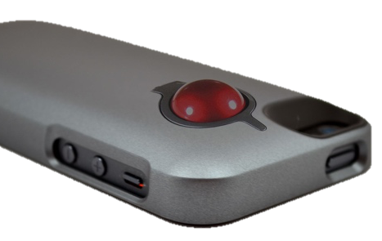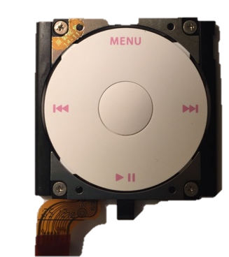
trackball single click wheel click wheel base on phone case
Explorations
Based on the scenarios above, we spent much time considering which type of design could give VI people comfortable and convenient interface experience. According to search some similar products combined the functions of directions, scrolling movement and Voiceover as well, the product came to our mind was the “mouse”, which combines almost has all the functions we need.
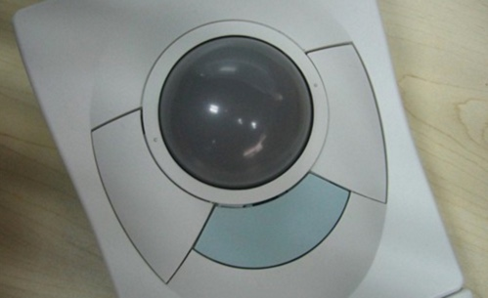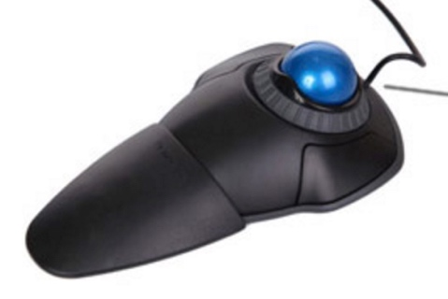
Firstly, it has a trackball which can show the guidance quick and smoothly. Second is that it is easy to take out, and can be used as an external device. However, considering the idea of “simple is the best”, we do not want VI people to take many devices to go out since they already have many inconveniences in their daily life, and we turn to another device which has the direction button on the phone case that when we hold the mobile phone, it is easy to touch the back button with one hand. For that reason, we also find LG has this kind of button on the back several years ago, but only used for selfie.
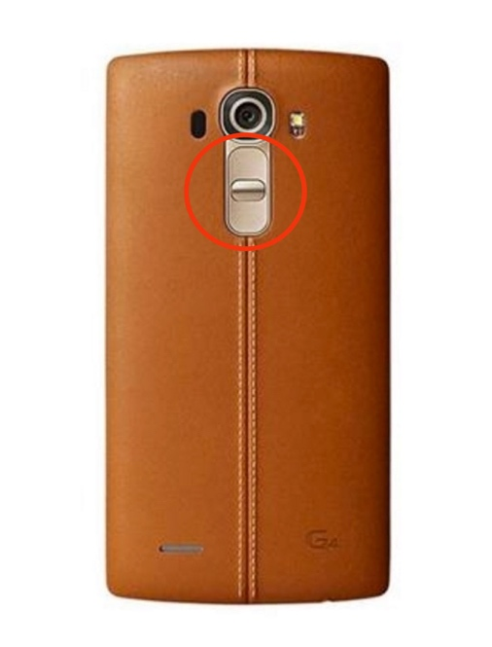
(the red circle is the back button)
Thus, what if we mix these two materials together and make a new back case design? Apparently, there is also a similar design which helps us a lot. Since iPod Nano has the touch pad on it, so we think about that whether it is possible for us to redesign it, which means that the back pad has functions of directions, scrolling movement, and connected to Voiceover as well.
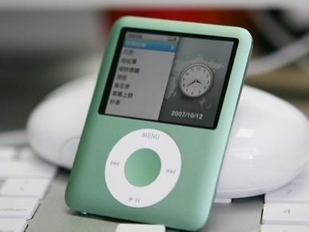
iPod Nano
1.3 Reflection-in-action
Technical issues
To realize the interface mentioned above, we just need to refer to the existing iPod wheel. And just like would we have mentioned in section “Constraints and assumptions”, we could use the technology of headphone jack and blue tooth to control the phone with an external device easily. The details could be find in the interim report.
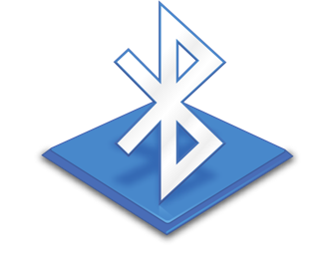
Headphone jack Booth tooth
Experiment
We explored all the functions VoiceOver could realize and what signals the audio jack could transfer. With these experiments, we think our product is implementable.
Expected Resources
There are three kind resources which are very significant in this design and have been explained in the interim report:
- The patent resource
- The communication with VI people
3. The technical resource
Acceptance of stakeholders, the relationship to “measure of success”
Generally, from the feedback from Mr. Mok, we believe the stakeholders are very satisfied with our design of click wheel. To analyze the functionality of our product, we simulated a scenario and ask Mr. Mok to finish a series of operating tasks to judge whether our product is well designed. We are observing how Mr. Mok operate the click wheel and realizing the corresponding function of the specific movement in another phone. By doing so, we could roughly show how our product works without a solid, tangible and functional product.
The acceptance level of stakeholders is closely linked to our “measure of success”, because we would like to create an easy-to-use product which could offer the physical touching feeling. How satisfied our stakeholders are will affect a lot on whether our product is successful.
The prototype
We stuck the click wheel on the phone case to build the prototype. Although the prototype is not functional, just like what have mentioned before, we simulated an implemented click wheel by operating another phone while observing the interviewee’s finger movement.

the prototype
1.4 Reflection-on-action
Production Plan
The most important resources in design process have been mentioned in the “Expected Resources” part under section 1.3. However, different resources are needed in production. The expected resources are roughly the same as the resources an electronic manufactory has. The manpower will profession skills, the machines for mass production, the raw materials and so on.
So the best and easiest production plan is to assign the production task to an electronic manufactory. We need to offer the design and all the technical details. Then, the manufactory could design the circuit and start the production. We believe it is a relatively realistic plan if we have enough money and time.
Although we plan to assign the production to electronic manufactory, it does not mean that there will never be any oversight. There are still some potential risk such as that the technology power of small manufactory is not enough to create our product while the big electronic manufactory is too experience. So, we need to keep a balance between the expense and the quality and make sure we make right choice.

The important scenarios and understanding of stakeholders
We think we have made a satisfactory video simulation which includes the most important scenario that a VI person walking outside with his or her white cane while the phone gets several notifications. This scenario shows the urgent need of freeing one hand to operate the phone, because VI people could not easily control the phone with one hand while the other one is occupied by the white cane.
The technical details
The technical details are mainly about the exact data of the click wheel’s size, position, materials and so on. We will offer some data here:
- The diameter of the wheel is 31.2mm.
- The diameter of the Main button is 10mm.
- The distance between the wheel and the long side is 17.9mm.
- The distance between the wheel and the top side is 19mm.
- The material is plastic and metal. (Surface is plastic and the internal structure is metal)
If technology available, we would like to make the position of the click wheel adjustable. So that users could customize the wheel and find the most comfortable position.

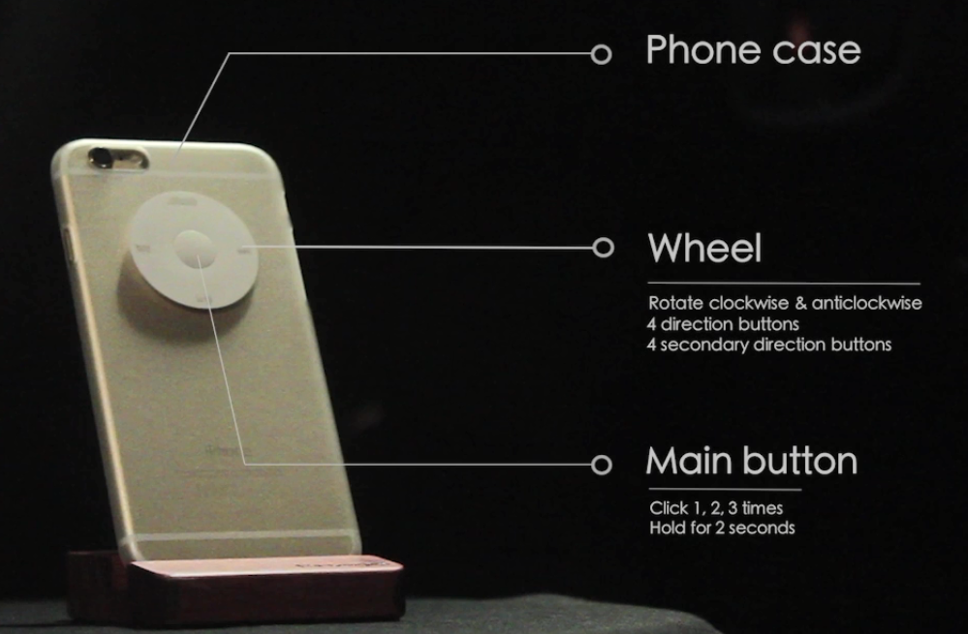
The way to present the design process
To present the design process, firstly, we would like to talk about the existing problem and our aims. Then we will present the communication with our target users or stakeholders including their feedback, evaluation, needs and so on. Afterwards, we may describe important scenarios to convince our stakeholders of the significance of our product. Besides we will briefly introduce the related technology and finally we will move to the product description part to explain why we make such design and how the product works. Last but not least, the potential value and future work will be mentioned before the Q&A part.
- The Finalized Design
The product description and how to use our product have been explained in the simulation video in details, so we will focus on how we finalize our design, the evaluations and the potential value of our product.
During the first evaluation of our prototype with Dr. Choy, we have faced a big issue about our prototype. Dr. Choy pointed out the problems of directing a wheel into a two dimensional platform and our team started to think about finding new ways to sort this problem. At first, we thought about giving up on the wheel idea and finding another way to direct our main screen with 8 direction buttons. With this decision we faced another problem, which was the starting point. While using the touch screen with two hands, the user could place the finger on any spot on the screen and the VoiceOver starts to direct the user from the located area. However, if we were going to control the screen with direction buttons, we needed a starting point. This could create a lot of confusion for the user and would be inconvenient to use.
Afterwards we have discovered a VoiceOver function called Item Chooser. Item chooser is a function that lists all the items on the screen in linear platform. This function brought our wheel back to the project and we decided to design the functions depending primarily on the Item Chooser function.
We took Item Chooser as our primary function to direct the phone with Click Wheel, before taking any action (except shortcuts), the user is expected to turn the Item Chooser on to switch to the linear platform to easily direct the screen from top to bottom.
During our evaluation with Mr. Mok, we used a separate phone to imitate Mr. Mok’s actions. We gave him a phone with Click Wheel attached to its case and first asked him about the convenience of the shape. We received a good feedback on the convenience and size of our prototype. To test actions, Mr. Mok followed the instructions which were given to him by us to direct the wheel. Our team was imitating his actions on a separate phone and he could hear the VoiceOver directory sounds to understand where he is located. We received a very good feedback after evaluation with Mr. Mok and he made us realize that our product is not only helpful for visually impaired people but also can be used by other people with disabilities.

- Achievements and Difficulties
To make a conclusion, we would like to describe the achievements and difficulties of our project.
Initially, we hopefully want to present a complete facility in order to help VI people to use their smartphone more conveniently. As we focus on the idea of click wheel, which offers VI people another dimensional choice of using the smart phone instead of using the traditional way to use cellphone, like screen touching, however, there were also some obstacles in front of us.
For instance, firstly was how to connect the click wheel with smartphone. Because of lack of technology and programming knowledge, we have no ideas to make them into connected. As we consulted the professional engineer from whom gave us the answer was that connection through Bluetooth related to security risk, so that currently it was unable to get the permission of authorization.
Secondly was the patent. We tested numbers of devices in order to choose the best matched one to our prototype, and the device which similar with iPod wheel became our final decision. If click wheel will go to the market, this is also a problem we need to solve.
Although such difficulties we met, we still got confidence from Mr. Mok who gave us high evaluation and certainty of the click wheel. When we were testing the device, he thought it was the “real” device which could run well.
Additionally, we also contacted with Information Accessibility Research Association in Shenzhen to display our device to them, they got interested with our ideas and were willing to help us as well.

